**UACluster2**

**VMClusterManager utility v. 1.0 user guide**

TARAS SHEVCHENKO NATIONAL UNIVERSITY OF KYIV

Published: September 2010

Author: Ivan Bilokon

**Abstract**

This guide helps you to be familiar with VMClusterManager utility which is a part of UACluster2 project. For more information about UACluster2 please refer to [UACluster2 Web site](http://uacluster2.codeplex.com/).

**Contents**

Overview 3

Getting started 4

System requirements 4

Deployment 4

Usage 5

Host management 5

Host group manipulation 6

Host manipulation 6

Virtual Machines management 6

VM group manipulation 7

Virtual Machine manipulation 7

VM snapshots manipulation 8

HPC job and task management 8

# Overview

The VMClusterManager is configuration and management utility for UACluster2 HPC Computing Cluster based on Hyper-V Virtual Machines (CCVM). It is designed to meet following requiremens:

* Unified user interface for all CCVM aspects handling, such as physical computers (PC), Virtual Machines (VM), Microsoft Hyper-V, tasks that are running on the cluster and so on.
* PC and VM bulk management and monitoring ability within LAN.
* Tasks bulk monitoring and controlling ability.
* User accounts and CCVM resources access policies management ability.
* Ability to protect the cluster from intentional or accidental injury by means of Operating System OS.

As the utility is currently in development, VMClusterManager version 1.0 has following functionality (which is less than described earlier):

* VM hosts management
  + Adding and removing hosts
  + VM host’s CPU and memory resources monitoring
  + VM hosts grouping
* VM management
  + VM location monitoring
  + VM grouping
  + VM state, snapshots, CPU and memory configuration monitoring and management
  + Connection to VM desktop
  + Getting job and task list running on selected VMs
  + VM bulk management
* HPC job and task management
  + Cancelling and requeueing jobs which are running on selected VMs
  + Cancelling and requeueing tasks which are running on selected VMs

Note: this utility also can be used as standalone virtual machine manager for Hyper-V VM without any cluster pack.

# Getting started

As the main function of VMClusterManager utility is UACluster2 computing cluster management it is assumed that user has all Microsoft HPC 2008 necessary components for UACluster2 already installed. For more information about UACluster2 deployment process please refer to [Documentation](http://uacluster2.codeplex.com/documentation).

## System requirements

* Microsoft Windows Server 2008 or Microsoft Windows Server 2008 R2 with Hyper-V role[1]
* Microsoft HPC 2008 Pack components for Head Node[2]
* .NET 3.5 or higher

## Deployment

Firstly you need to download and install [VMClusterManager package](http://uacluster2.codeplex.com/releases/view/48650). You can install package to any computer in HPC Cluster’s Active Directory domain. After installation you can start the program and work with it. The application needs administrator permissions to work properly.

# Usage

Main window of the application is divided into 3 parts: Navigation, Details and Actions (see Fig. 1 for more details). 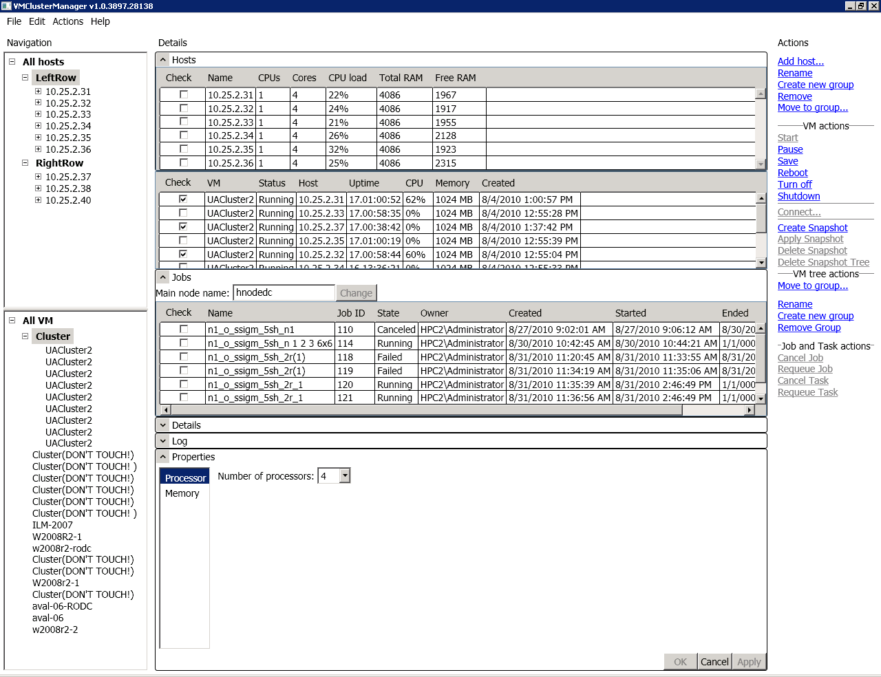

Fig. 1 VMClusterManager utility user interface.

Navigation contains two tree views to navigate through host and VM structures.

Details contain controls for HPC cluster instances monitoring and management.

Actions contain hyperlinks allowing you perform some operations on selected objects.

## Host management

You can perform following actions:

* Adding, removing, host groups
* Adding singe host or host range
* Removing single host
* Moving host group to another host group
* Moving host list to another host group
* Renaming host group
* Monitoring host’s CPU and RAM resources

### Host group manipulation

Initially there is single root host group called “All hosts”. This group can only be renamed. It is not allowed to remove or to move it to another host group.

To add a host group you need to select host existing host group which you wish to be parent. After that “Create new group” action will be activated on Actions panel. You can change group name just after creating it or later by performing “Rename” action or pressing F2 on selected group.

You can remove empty group by performing “Remove” action or pressing “Delete” on selected group.

You can move group to another group by performing “Move to group…” action and selecting parent group in dialog. After that group with its child hosts will become child of a group selected in dialog.

Note: moving group may take several seconds;

### Host manipulation

To manage your virtual machines firstly you need to add its hosts. Hosts should be added as children of some host group. To perform this select host group and click to “Add host…” action. You can specify a single host name or IP address or IP address range to add multiple hosts.

After adding host/hosts VMClusterManager begins receiving its VMs. “+” near host name in host tree means that VM information from the host received successfully and you can expand it to see what VMs are located on the host. In other case if there is no “+” near host name it may mean following:

* VM information is still receiving;
* There is no VM on the host;
* Some error occurred (you will receive an error message in that case).

You can remove host from its parent group. In that case you won’t be able to manage its VMs. To remove host select it in host tree and click “Remove” action.

To explore host’s CPU and RAM resources select host group containing hosts you wish to monitor and expand “Hosts” expander on Details panel. You can sort entries by clicking corresponding column header. Also you can check all hosts or uncheck all by clicking “Check” header and selecting appropriate menu item.

Note: if selected group has many hosts expanding host’s details may take several seconds.

To move some hosts to different group you should expand “Hosts” end check hosts you wish to move. Then click “Move to group…” action and choose group you wish hosts move to.

Note: moving hosts may take several seconds.

## Virtual Machines management

You can perform following actions:

* Adding, removing, VM groups
* Moving VM group to another VM group
* Moving VM list to another VM group
* Renaming VM group
* Modifying VM state: Start, Pause, Save state, Reboot, Turn off, Shutdown
* Connecting to VM desktop
* Creating, applying, deleting snapshots
* Modifying memory and processor on selected VM list
* Monitoring VM properties and details.
* Monitoring HPC Jobs and Tasks located on selected VM list

In Navigation you can see VM tree. You can modify this tree by creating new groups, moving VMs and groups to groups. VMs can be grouped. Groups can be created or renamed via pressing corresponding action in Actions while some group is selected in VM tree.

### VM group manipulation

VM group manipulation is the same as host group manipulation. Please, refer to Host group manipulation for more details.

### Virtual Machine manipulation

To manage VM or several VMs you should select its parent group. Details panel shows you list of VM which are direct members of selected group. Here you can see various VM properties. Also you can sort entries by clicking corresponding column header.

You can check some VMs in checkbox column you wish to manage. Actions you can perform on selected VMs will be active. Ability to perform action on selected VMs means that the action can be performed at list on one VM from selected list (exception is Connect action which can be performed only if single VM is checked). So, for example, if you check 10 VMs, 2 of which are in Running state and others are turned off, action Start will be active. If you perform Start action turned off machines will start and running VMs will take no action. In addition you receive 2 warning log messages saying “Operation is not valid due to the current state of the object” because you running VMs cannot start. You can look at log messages by expanding “Log” expander at the bottom of Details panel.

Also you can check all VM or uncheck all by clicking “Check” header and selecting appropriate menu item.

It is important to say a few words about logging. In the current version log messages are being written only in case of performing some action on more than 1 VM selected. If only 1 VM selected error messages arise in message boxes and not present in log.

VM state change actions which cannot be performed due to current VM state are inactive.

Renaming VM is not implemented yet.

You can explore VM details such as VM screen Thumbnail image, VM name, VM computer name (network name), VM status, VM Operating system name and version, VM IP address, snapshots tree. To perform this you can check single VM and expand Details expander.

Note: VM network name, OS name and version, IP address is available only if VM OS is running and Hyper-V integration components are installed. IP address is not available before Windows Server 2008 R2 host’s OS.

You can explore HPC jobs related to selected VMs by expanding “Jobs” expander on Details panel. You may need to change Head Node name before. Default Head Node name is “localhost”. If you run VMClusterManager on machine other than head node you need to change Head Node name value. To perform this, modify the value in Head Node name textbox (located at the top of Jobs expander) and click “Change” button.

Note: it may take several seconds to expand Jobs.

To explore related tasks inside a job you can select grid row which represents a job. You will get task list like in Fig. 2.

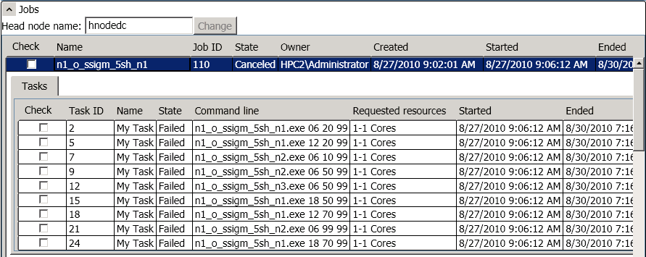

Fig. Exploring HPC tasks inside job.

### VM snapshots manipulation

Snapshot tree for selected VM you can find in expander in the bottom of Details expander in case it is expanded and single VM selected.

Bold snapshot represents the most current VM snapshot.

You can create snapshots for selected VM list. Note: you will receive notification about progress and status of the operation in case of error only.

If you select any snapshot in snapshot tree available snapshot actions will become active. Note: snapshot actions which cannot be performed due to current VM state are inactive.

## HPC job and task management

You can perform following actions:

* Cancelling and requeueing selected jobs
* Cancelling and requeueing selected tasks

If you check some jobs (tasks) in job (task) list available job (task) actions on selected list will become active on Actions panel (see Virtual Machine manipulation to learn how to watch job (task) list for VM).

Note: Warning! Cancelling job on particular VM causes cancelling the job on other VMs (this is because the same job may run on several VMs). For complete job management and monitoring use HPC 2008 Cluster Manager utility.

1. Meeting the Hyper-V role requirement is essential for VM Desktop connection proper operation only.
2. To manipulate VM only without HPC jobs and tasks manipulation, you can use any Windows Server 2008 (or even Windows XP if VM Desktop connection is not needed) PC in HPC Cluster’s Domain.